**Experiment 6.1**

**Student Name:** Sahil Kaundal **UID:** 21BCS8197

**Branch:** BE CSE (Lateral Entry) **Section/Group:** 616/A

**Semester:** 6th **Date of Performance:** 04/04/2023

**Subject Name:** CC-2 Lab **Subject Code:** 20CSP-351

1. **Aim/Overview of the practical:**

Is Graph Bipartite?

There is an **undirected** graph with n nodes, where each node is numbered between 0 and n - 1. You are given a 2D array graph, where graph[u] is an array of nodes that node u is adjacent to. More formally, for each v in graph[u], there is an undirected edge between node u and node v.

<https://leetcode.com/problems/is-graph-bipartite/>

1. **Apparatus / Simulator Used:**

* Windows 7 or above
* Google Chrome

1. **Objective:**

* To understand the concept of Graphs.

A Graph is a non-linear data structure consisting of vertices and edges. The vertices are sometimes also referred to as nodes and the edges are lines or arcs that connect any two nodes in the graph. More formally a Graph is composed of a set of vertices( V ) and a set of edges( E ). The graph is denoted by G(E, V).

1. **Code:**

class Solution {

public:

    bool isBipartite(vector<vector<int>>& graph) {

        int len = graph.size();

        stack<int> s;

        vector<int> vis(len);

        for (int i = 0; i < len; i++) {

            if (vis[i] > 0) continue;

            vis[i] = 1;

            s.push(i);

            while (s.size() > 0) {

                int curr = s.top();

                s.pop();

                vector<int> edges = graph[curr];

                for (int next:edges)

                    if (vis[next] == 0) {

                        vis[next] = vis[curr] ^ 3;

                        s.push(next);

                    } else if (vis[curr] == vis[next]) return false;

            }

        }

        return true;

    }

};

**4. Result/Output/Writing Summary:**

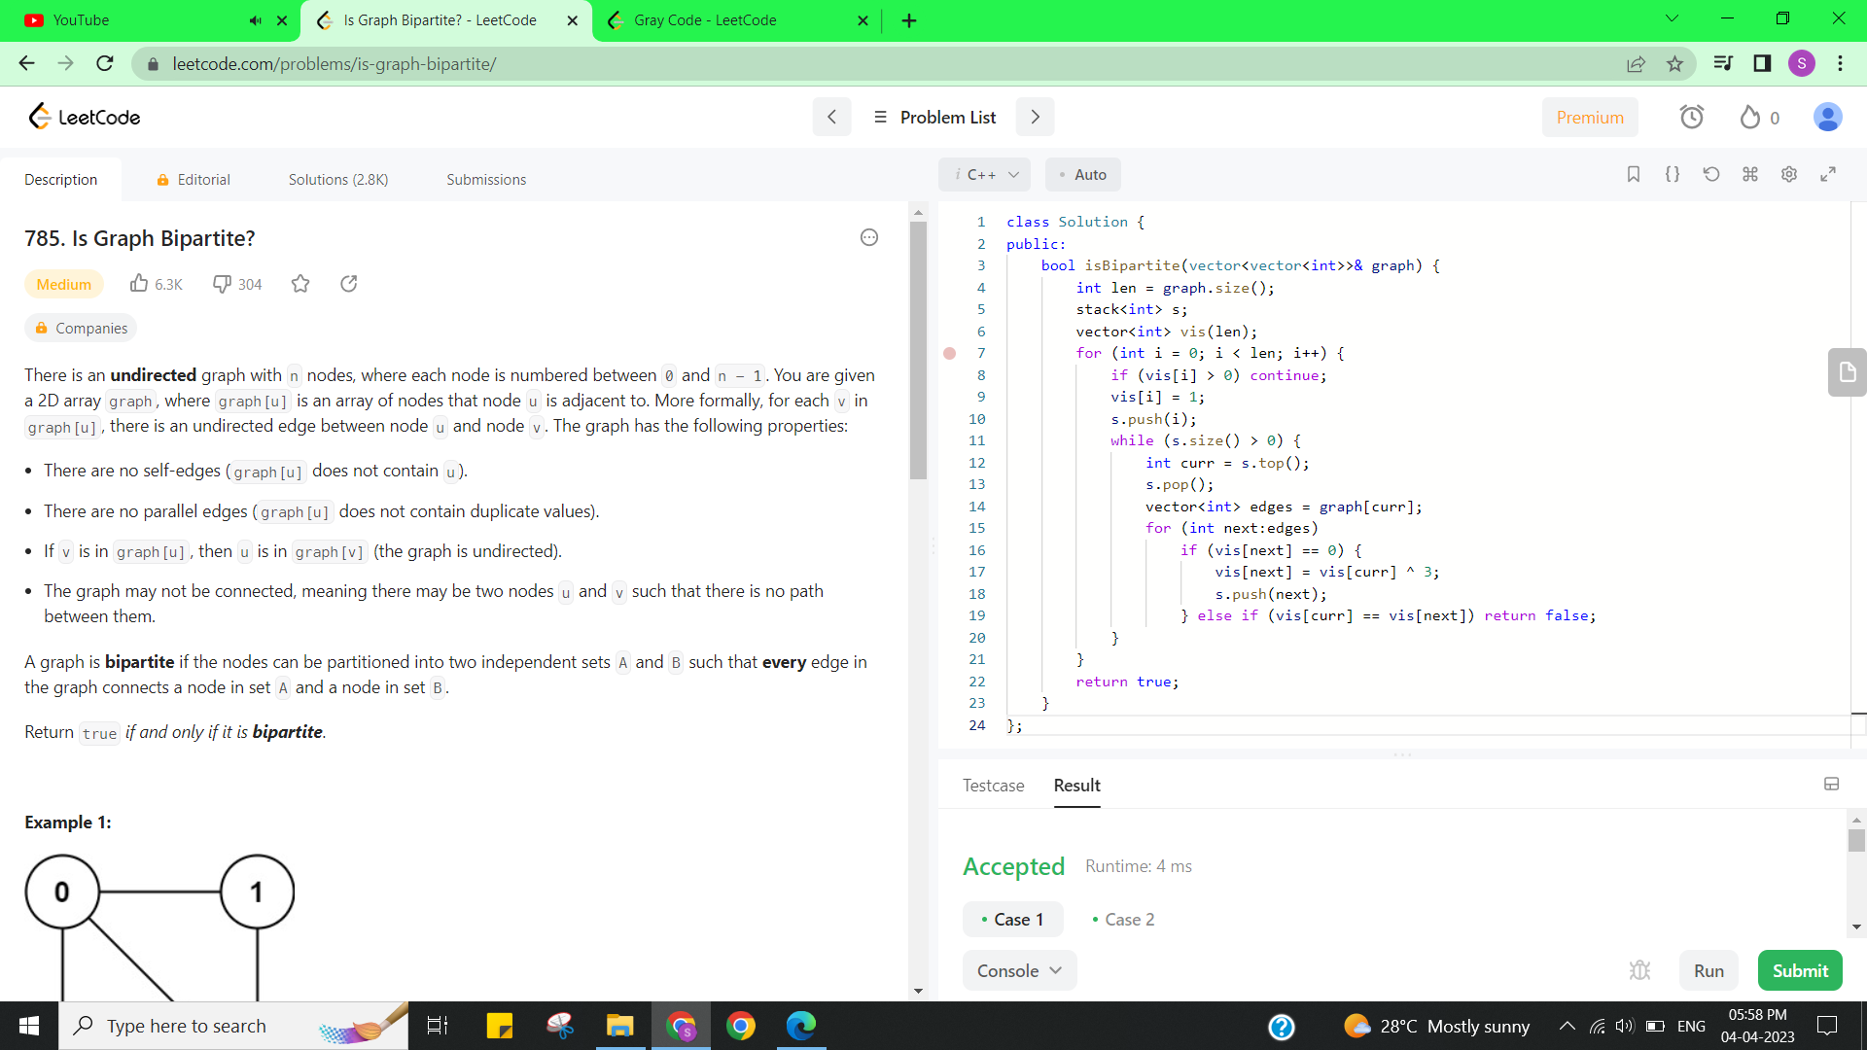

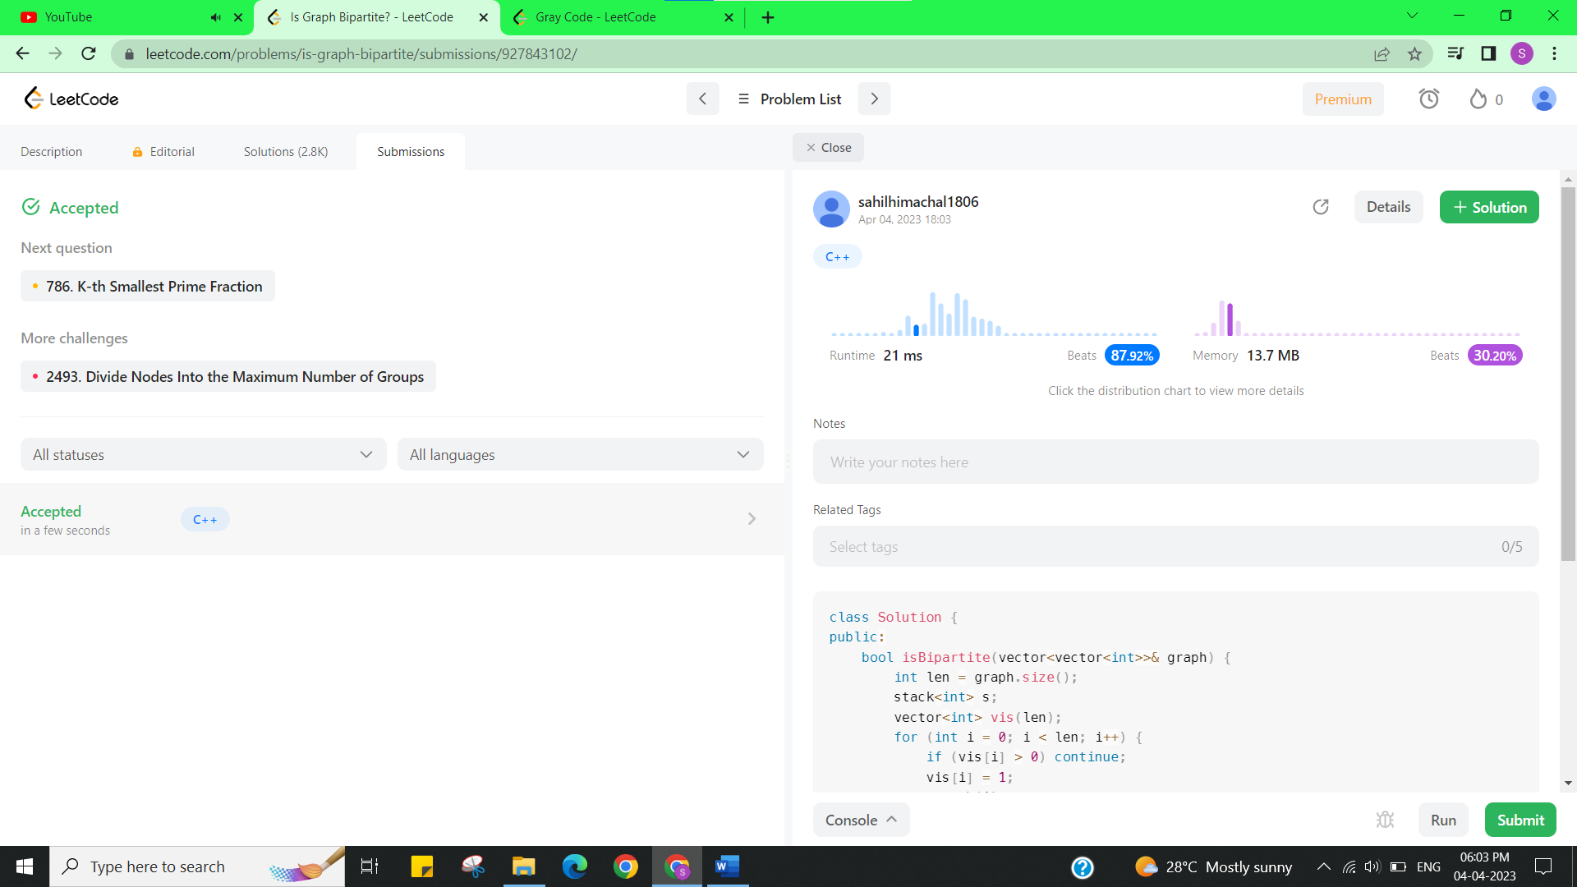

**Experiment 6.2**

1. **Aim/Overview of the practical:**

Gray Code

An **n-bit gray code sequence** is a sequence of 2n integers where:

Every integer is in the **inclusive** range [0, 2n - 1],

<https://leetcode.com/problems/gray-code/>

1. **Apparatus / Simulator Used:**

* Windows 7 or above
* Google Chrome

1. **Objective:**

* To understand the concept of Graphs.

A Graph is a non-linear data structure consisting of vertices and edges. The vertices are sometimes also referred to as nodes and the edges are lines or arcs that connect any two nodes in the graph. More formally a Graph is composed of a set of vertices( V ) and a set of edges( E ). The graph is denoted by G(E, V).

1. **Code:**

class Solution {

public:

vector<int> grayCode(int n) {

        if(n == 0) return {0};

        vector<int> ret = {0, 1};

        for(int i=2; i<=n; i++)

            for(int j=ret.size()-1; j>=0; j--)

                ret.push_back(ret[j]+(1<<i-1));

        return ret;

        }

};

1. **Result/Output/Writing Summary:**

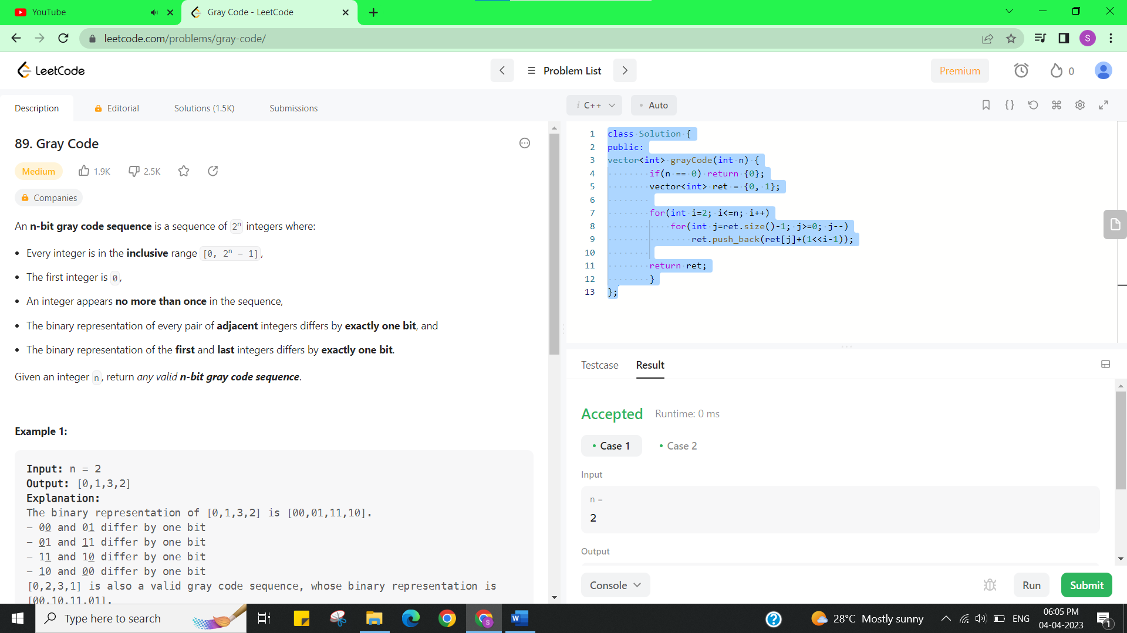

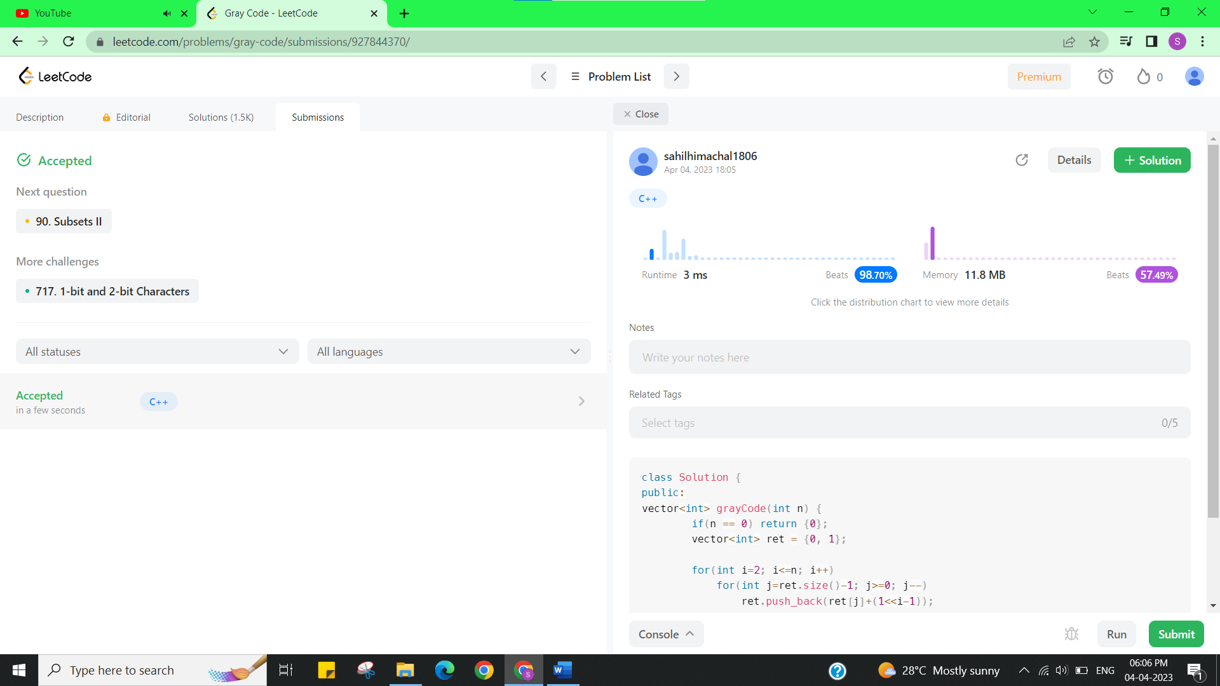

**Learning outcomes (What I have learnt):**

* Learned the concept of Graphs.

**Evaluation Grid (To be created as per the SOP and Assessment guidelines by the faculty):**

|  |  |  |  |
| --- | --- | --- | --- |
| Sr. No. | Parameters | Marks Obtained | Maximum Marks |
| 1. |  |  |  |